Machine Learning-Based Drug Repurposing Discovery for Disordered (Non-Globular) MYC and CTNNB1 Oncoproteins



Computer Engineering
Senior Design Project Report

Advisor: Assoc. Prof. Dr. Tuğba Önal SÜZEK

Beyza Yörük
Date: 12/01/2026
Machine Learning-Based Drug Repurposing Discovery for Disordered (Non-Globular) MYC and CTNNB1 Oncoproteins
Beyza Yörük
Computer Engineering

Summary

The MYC and CTNNB1 oncoproteins, which play a critical role in cancer treatment, are considered 'undruggable'. The main reason for this is their intrinsically disordered protein (IDP) structures, which lack stable pockets suitable for traditional drug discovery. This project aims to develop a machine learning (ML) based drug repurposing strategy by filling the methodological gap in the literature for these challenging targets. The project's method is based on training ML models such as Random Forest and Graph Neural Networks (GNN) with bioactivity data collected from databases like ChEMBL (≥850 active molecules). These models will be used to screen candidates with potential MYC-MAX and β-catenin-TCF4 protein-molecule interaction from the PubChem database. The best 'hit' candidates will be computationally validated through molecular docking and 100 ns molecular dynamics (MD) simulations. The 12-month project will be managed under five work packages (WP): data collection, model development, virtual screening, simulation, and reporting. The main impact of the project is to contribute to the scientific literature by presenting an innovative computational method for 'undruggable' targets and to create a list of candidate molecules that will form the basis for advanced experimental studies.
Keywords: Machine Learning, Drug Repurposing, Disordered Proteins, MYC, CTNNB1

Table of Contents
1. Introduction 4
2. Methods 5
2.1 Data Collection and Preprocessing 5
2.2 Machine Learning Model Development and Optimization 5
2.3 Virtual Screening and Hit Molecule Identification 5
2.4 Molecular Dynamics Simulations and Free Energy Calculations 6
3. Results 6
4. References 7

- Introduction

Cancer is one of the most important health problems worldwide, and identifying molecular treatment targets is critically important. MYC and CTNNB1 (β-catenin) oncoproteins are overexpressed or mutated in many cancer types. MYC is a transcription factor that plays a central role in cell proliferation and metabolism, and its overactivation is observed in many cancers [4]. The β-catenin protein, encoded by the CTNNB1 gene, is a key effector of the Wnt/β-catenin signaling pathway; APC mutations are found in 81.9% of colorectal cancers, and direct CTNNB1 mutations are found in 48% [1]. These high mutation rates show that both proteins are critical targets in cancer treatment. However, MYC and β-catenin are considered "undruggable" because they contain intrinsically disordered protein regions (IDPs). These disordered structures make them different from classical drug targets with deep binding pockets and cause traditional structure-based drug design methods to fail [1]. This situation results from the fact that the dynamic nature of IDPs cannot be represented by methods based on the classical "lock and key" model, and there is insufficient experimentally validated interaction data for these proteins. In the literature, most studies conducted on IDP oncoproteins (e.g., MYC, CTNNB1, p53, KRAS) focus on in vitro, in vivo, or molecular dynamics (MD)-based structural characterizations. On the other hand, research in the field of machine learning-based ligand binding prediction is extremely limited. Recently published studies emphasize that the lack of training data still creates a major bottleneck in IDP-targeted drug design [12, 14] and that rational IDP-drug discovery methods need to be critically developed [13, 14].
Research Question: Can potential inhibitors targeting disordered MYC and CTNNB1 oncoproteins be predicted using machine learning models based on bioactivity data? Hypothesis: Machine learning models that learn from large-scale bioactivity data can identify effective binders for disordered proteins, independent of protein conformational heterogeneity. This project aims to fill the critical gap in the literature by presenting a pioneering approach that directly predicts ligand binding potential with bioactivity-based artificial intelligence models without considering the conformational diversity of IDPs. Thus, it aims to demonstrate the applicability of machine learning-focused ligand recognition strategies for disordered proteins such as MYC and β-catenin, which are considered "undruggable," and to address the methodological deficiency in this field. The studies by Lehrich and colleagues targeting β-catenin [5] and Singh and colleagues targeting the MYC protein [9, 10] have experimentally confirmed that these proteins can be used as drug targets.

The main aim of our project is to identify potential drug candidates that can target the disordered MYC and CTNNB1 oncoproteins, where traditional drug development methods have failed, using a machine learning supported drug repurposing strategy [11] in silico.

Concrete Objectives:
  - Development of high-accuracy machine learning models: To develop classification models that will predict molecules capable of disrupting MYC-MAX and β-catenin-TCF4 protein-protein interactions using Random Forest, Gradient Boosting Machines, and Graph Neural Network algorithms with bioactivity data obtained from ChEMBL, PubChem, and BindingDB databases (≥10,000,000 molecules) (target performance: AUC ≥ 0.95).
  - Identification of hit molecules: To identify potential hit molecules with low toxicity scores that can be repurposed by screening the PubChem BioAssay database using the developed models.
  - Computational validation: To validate the binding affinities and stabilities of the highest-scoring hit molecules (n≥5) through molecular docking (AutoDock Vina, Glide), molecular dynamics simulations (100 ns), and MM-GBSA free energy calculations, creating a prioritized candidate list ready for advanced experimental studies.

- Methods

To achieve project objectives, the analytical and computational methods to be applied are organized under five main work packages. Our methods are inspired by the QSAR-ML workflow applied for Tankyrase inhibitors by Sharma and Arumugam [8] and the Bayesian machine learning-based drug repurposing for GSK3β conducted by Vignaux and colleagues [11].

2.1 Data Collection and Preprocessing
Bioactivity data targeting MYC-MAX and β catenin-TCF4 protein-molecule interactions will be collected from ChEMBL, PubChem, and BindingDB databases. In the PubChem BioAssay database, there are 850 active and 16,689 inactive molecules in 98 experiments containing active molecules on the MYC target protein. In the PubChem BioAssay database, there are 1,359 active and 193,002 inactive molecules in 189 experiments containing active molecules on the CTNNB1 target protein.

2.2 Machine Learning Model Development and Optimization
Classification models will be developed with three different machine learning algorithms (Random Forest, Gradient Boosting Machines, Graph Neural Networks). Sharma and Arumugam increased the Random Forest model to 98% AUC value with systematic hyperparameter optimization [8]. Hyperparameter optimization will be performed with Grid Search and Randomized Search methods, and model performance will be evaluated with 10-fold cross-validation. AUC, precision, recall, and F1-score will be used as model performance metrics. Noor and colleagues have proven that Graph Neural Network models show significantly higher performance (99% accuracy) than traditional methods (82% accuracy) [7].

2.3 Virtual Screening and Hit Molecule Identification
The developed machine learning model will be applied to screen candidate molecules with available activity and low toxicity scores in the PubChem database. Molecules predicted as "active" by the model (prediction score ≥ 0.80) will be subjected to computational validation with molecular docking. Using AutoDock Vina and Glide software, the docking of hit molecules to MYC-MAX (PDB: 1NKP, 6G6K) and β-catenin-TCF4 (PDB: 1G3J, 2GL7, 1JPW) protein molecule interaction surfaces will be simulated [6]. By analyzing docking scores (ΔG < -7.0 kcal/mol) and binding modes, the highest-scoring 20-30 hit molecules will be selected.

2.4 Molecular Dynamics Simulations and Free Energy Calculations
For the selected hit molecules, 100 ns molecular dynamics (MD) simulations will be performed using GROMACS or AMBER software. During MD simulations, stability analysis of the protein-ligand complex (RMSD, RMSF), hydrogen bond formation, and interaction energies will be monitored.

- Results

Hit molecules that pass computational validation will be prepared as a detailed project results report. The report will include machine learning prediction scores, molecular docking results, MD simulation analyses, MM-GBSA free energy calculations, and pharmacokinetic predictions (ADMET profiles) for each candidate molecule. The report will be converted into an article as a conference paper.

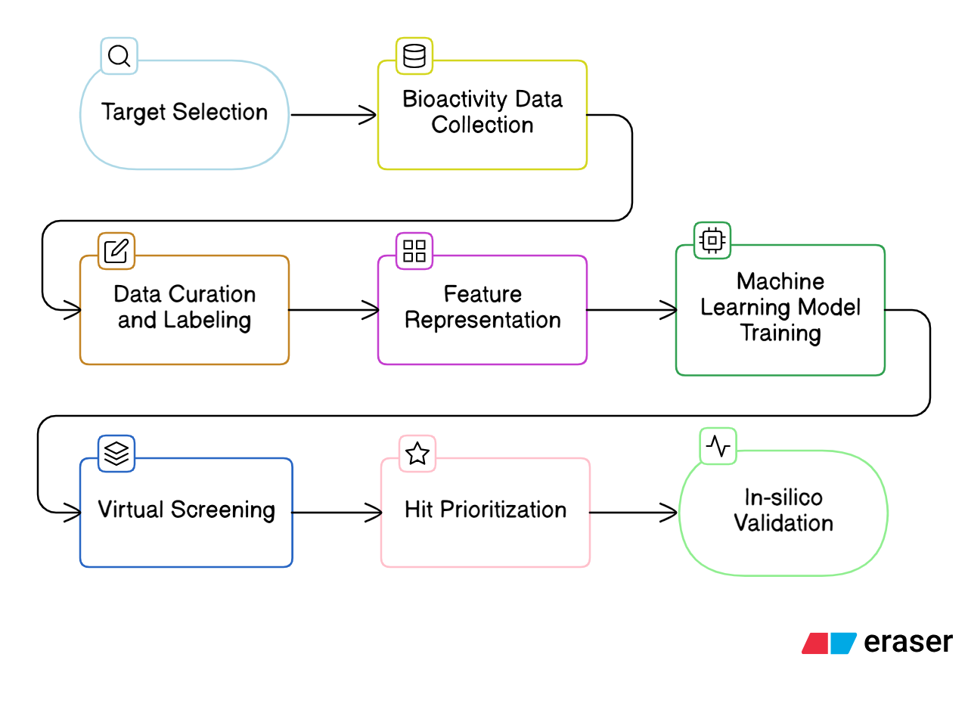
Representation of the Project

4. References

[1] Chen, S., Lin, T., Basu, R., Ritchey, J., Wang, S., Luo, Y., Li, X., Pei, D., Kara, L. B., & Cheng, X. (2024). Design of target specific peptide inhibitors using generative deep learning and molecular dynamics simulations. Nature Communications, 15(1), 1611. https://doi.org/10.1038/s41467-024-45766-2
[2] Cui, C., Zhou, X., Zhang, W., Qu, Y., & Ke, X. (2018). Is β-Catenin a Druggable Target for Cancer Therapy? Trends in Biochemical Sciences, 43(8), 623-634. https://doi.org/10.1016/j.tibs.2018.06.003
[3] Díaz-Eufracio, B. I., & Medina-Franco, J. L. (2022). Machine Learning Models to Predict Protein-Protein Interaction Inhibitors. Molecules, 27(22), 7986. https://doi.org/10.3390/molecules27227986
[4] Fatima, I., Khurshid, A., Javaid, N., Asghar, A., Rasool, N., Rana, M., Imran, M., & Hanif, M. (2024). Discovery of Small Molecule Inhibitors Targeting CTNNB1 (β-catenin) for Endometrial cancer: Employing 3D QSAR, Drug-Likeness Assessment, ADMET Predictions, Molecular Docking and Simulation. Current Medicinal Chemistry. https://doi.org/10.2174/092986732507240826111754
[5] Fioresi, R., Demurtas, P., & Perini, G. (2022). Deep learning for MYC binding site recognition. Frontiers in Bioinformatics, 2, 1015993. https://doi.org/10.3389/fbinf.2022.1015993
[6] Hammoudeh, D. I., Follis, A. V., Prochownik, E. V., & Metallo, S. J. (2009). Multiple Independent Binding Sites for Small-Molecule Inhibitors on the Oncoprotein c-Myc. Journal of the American Chemical Society, 131(21), 7390-7401. https://doi.org/10.1021/ja900616b
[7] Karadkhelkar, N. M., Lin, M., Eubanks, L. M., & Janda, K. D. (2023). Demystifying the Druggability of the MYC Family of Oncogenes. Journal of the American Chemical Society, 145(6), 3259-3269. https://doi.org/10.1021/jacs.2c12732
[8] Lehrich, B. M., Delgado, E. R., Yasaka, T. M., Liu, S., Cao, C., Liu, Y., Taheri, M. N., Guan, X., Koeppen, H., Singh, S., Meadows, V., Liu, J. J., Singh-Varma, A., Krutsenko, Y., Poddar, M., Hitchens, T. K., Foley, L. M., Liang, B., Rialdi, A., ... Monga, S. P. (2025). Precision targeting of β-catenin induces tumor reprogramming and immunity in hepatocellular cancers. Nature Communications, 16(1), 5009. https://doi.org/10.1038/s41467-025-60457-2
[9] Low, J. L., Du, W., Gocha, T., Oguz, G., Zhang, X., Chen, M. W., Masirevic, S., Yim, D. G. R., Tan, I. B. H., Ramasamy, A., Fan, H., & DasGupta, R. (2021). Molecular docking-aided identification of small molecule inhibitors targeting β-catenin-TCF4 interaction. iScience, 24(6), 102544. https://doi.org/10.1016/j.isci.2021.102544
[10] Noor, F., Junaid, M., Almalki, A. H., Almaghrabi, M., Ghazanfar, S., & Qamar, M. T. ul. (2024). Deep learning pipeline for accelerating virtual screening in drug discovery. Scientific Reports, 14(1), 28321. https://doi.org/10.1038/s41598-024-79799-w
[11] Sharma, D., & Arumugam, S. (2025). A machine learning-Assisted QSAR and integrative computational combined with network pharmacology approach for rational identification of tankyrase inhibitors in colon adenocarcinoma. Computers in Biology and Medicine, 197, 111068. https://doi.org/10.1016/j.compbiomed.2025.111068
[12] Singh, A., Kumar, A., Kumar, P., Nayak, N., Bhardwaj, T., Giri, R., & Garg, N. (2021). A novel inhibitor L755507 efficiently blocks c-Myc–MAX heterodimerization and induces apoptosis in cancer cells. Journal of Biological Chemistry, 297(1), 100903. https://doi.org/10.1016/j.jbc.2021.100903
[13] Singh, A., Kumar, P., Sarvagalla, S., Bharadwaj, T., Nayak, N., Coumar, M. S., Giri, R., & Garg, N. (2022). Functional inhibition of c-Myc using novel inhibitors identified through "hot spot" targeting. The FASEB Journal, 36(5). https://doi.org/10.1096/fj.202101942R
[14] Vignaux, P. A., Minerali, E., Foil, D. H., Puhl, A. C., & Ekins, S. (2020). Machine Learning for Discovery of GSK3β Inhibitors. ACS Omega, 5(41), 26551-26561. https://doi.org/10.1021/acsomega.0c03302

